Project Design Phase-II
Technology Stack (Architecture & Stack)

Date | 15 February 2026
Team ID | LTVIP2026TMIDS79623
Project Name | Educational Organisation Using ServiceNow
Maximum Marks | 4 Marks

Technical Architecture:
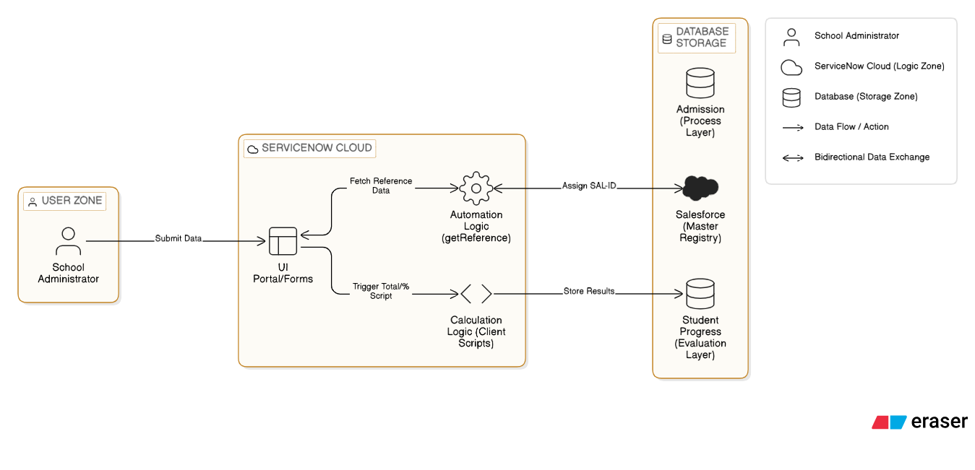
Table-1 : Components & Technologies:
S.No | Component | Description | Technology
1 | User Interface | How the School Administrator interacts with records. | ServiceNow Service Portal & Workspace UI (HTML, CSS, AngularJS)
2 | Application Logic-1 | Automated calculation of Total, Percentage, and Results. | ServiceNow Client Scripts (JavaScript)
3 | Application Logic-2 | Data retrieval and auto-population of fields. | GlideAjax & getReference (JavaScript)
4 | Application Logic-3 | Visual tracking of the admission lifecycle. | Process Flow Formatter (ServiceNow Native)
5 | Database | Core tables for storing Master Registry and Evaluation data. | ServiceNow Relational Database (MariaDB based)
6 | Cloud Database | Centralized hosting of student progress and admission tables. | ServiceNow Cloud (PDI)
7 | Infrastructure | Application deployment and development environment. | ServiceNow Personal Developer Instance (PDI)

Table-2: Application Characteristics:
S.No | Characteristics | Description | Technology
1 | Open-Source Frameworks | Scripting and UI frameworks utilized by the platform. | JavaScript (ES6), AngularJS
2 | Security Implementations | Access controls for sensitive student evaluation data. | ACLs (Access Control Lists), Read-only/Disabled UI Policies
3 | Scalable Architecture | 3-tier architecture separating UI, Logic, and Data layers. | ServiceNow Multi-instance Architecture
4 | Availability | Accessibility of the school management system. | ServiceNow Cloud Infrastructure (High Availability)
5 | Performance | Efficiency of real-time calculations and data fetching. | Asynchronous Client Scripts (GlideAjax)

